**2020/2021 GRANT APPLICATION**

**American Malting Barley Association, Inc.**

**Project Title:** Genetic Characterization of Germination Traits and Their Relationship to Pre-harvest Sprouting in Winter and Spring Barley

**Principal Investigator(s), institution, address, phone, email**

Mark Sorrells; Cornell University, 240 Emerson Hall, Ithaca, NY 14853; mes12@cornell.edu

**Executive Summary (non-technical terms)**

Winter and spring malting barley production has expanded to new regions across the country in recent years. As climate change continues to affect weather patterns across North America, opportunities for new winter malting barley acreage will increase but exposure to excess moisture conditions around harvest time could also increase. Excessive moisture after physiological maturity (PM) increases the risk of pre-harvest sprouting (PHS), causing the grain to sprout in the field before it is harvested. Selection for superior malting quality in varieties bred for drier environments is often associated with low grain dormancy and PHS susceptibility. Barley lines with PHS resistance that are not sufficiently after-ripened have the opposite problem, not germinating or not germinating uniformly during malting. Some winter barley varieties display prolonged post-harvest dormancy resulting in increased grain storage costs for growers and malthouses. Developing an understanding of PHS and the dormancy period in both winter and spring malting barley germplasm would be a valuable resource for variety development. This project will expand on previous PHS/dormancy research in spring germplasm.

Prior AMBA-supported Cornell University research mapped both known and novel genomic regions associated with PHS, grain dormancy, and germination rate in a panel of two-row spring malting barley breeding lines (SMBB, n=416).This work also led to the discovery of a recombination between two closely linked genes associated with dormancy and germination at the *Seed Dormancy 2* (*SD2*) locus on chromosome 5H. A unique combination of variants at each gene appears to confer PHS resistance without compromising malting quality (Figure 1) but more work is needed to confirm and understand this interaction.

This grant would support a single-year project to 1) genotype and phenotype a collaborative set of winter/facultative barley doubled haploid (DH) lines developed by Oregon State University for PHS and for germination traits at three time points and 2) add to the existing Cornell spring barley PHS/dormancy dataset by further characterizing *SD2* recombinant lines, collecting another season of data on the SMBB, and phenotyping a diverse set of European landraces from the John Innes Centre, Norwich, UK (JIC) to identify unique alleles in the *SD2* region. Germination trait data collection for the winter and spring panels will be complete by December 2020. This project has two primary challenges. The first is a level of uncertainty about the winter hardiness of the DH lines. Even though winter hardy parents were used in the crosses, some of the lines may not survive the winter however, backup seed was produced in the greenhouse. The second challenge is the labor intensive germination phenotyping. Sampling grain for germination assays and subsequent phenotyping is highly time sensitive and time consuming. Securing adequate labor to phenotype both large populations is critical to the success of this project.

**Budget Information:** July 1, 2020 through June 30, 2021

**Budget Justification**

**Salary:** 370 hours of undergraduate labor at $13/hour: $5200

**Fringe Benefits:** None for student labor

**Materials and supplies:** 510 samples for 50k barley Illumina Infinium iSelect genotyping, $25/sample: $12,500. Genotyping will be carried out by the USDA Fargo Genotyping Lab.

**Indirect Costs:** Not permitted by AMBA.

**Total Direct Costs:** $17,700

**Objectives and Needs for This Project**

The objectives of this project are to genetically characterize sources of PHS resistance and grain dormancy and determine the persistence (duration) of dormancy in winter germplasm, and to better characterize the genetics of the *SD2* region in spring malting barley using diverse germplasm and a unique set of recombinant lines. This project would produce genome-wide marker data using the standard 50K array for a collaborative set of DH two-row winter/facultative lines, phenotypic data on dormancy duration and germination rate for winter/facultative barley, and phenotypic data to validate previous research characterizing variants at the *SD2* locus in spring barley. Growers and maltsters will directly benefit from characterization of post-harvest dormancy release and how germination rate changes over time in barley. They will also benefit directly from the confirmatory analysis of PHS resistant lines with high malting quality indicators (germination rate). Funds are requested to support:

1) Genotyping and phenotyping a winter malting barley DH population (n=510) developed by Oregon State University for PHS and grain dormancy (germination energy) and germination rate (germination index) at three timepoints across two locations.

2) Phenotyping the SMBB, the JIC, and the recombinant *SD2* lines (total n=527) for PHS and germination energy and germination index at three timepoints across two locations.

The winter barley DHs will be genotyped with the 50k barley Illumina Infinium iSelect genotyping array. This array is the densest genotyping array available for barley and will provide high quality genome-wide marker data that can be used for genome-wide association mapping and genomic prediction. The proposed research plan for this winter DH population was previously used to successfully identify genomic variants for PHS and germination traits in the SMBB and to characterize variation in dormancy release points. Previous AMBA-funded research resulted in the discovery of a putative recombination between GA20ox1 and MKK3 at the *SD2* locus in a single family. Both genes have been implicated in PHS and malting quality QTL mapping, and in the case of MKK3, gene cloning (Nakamura et al., 2016), but interactions between, and variants of the two genes in the same population have not been previously described. The haplotype associated with this recombination seems to confer PHS resistance, quick dormancy break and high germination rate, which may indicate high malting quality (Woonton, Jacobsen, Sherkat, & Stuart, 2005) (Figure 1). Additional phenotyping of this recombinant family may help elucidate the interaction of GA20ox1 and MKK3 variants. Adding additional germplasm to the SMBB and including the JIC panel, will improve mapping and understanding of previously described and novel genomic regions associated with PHS, grain dormancy, grain germination and malting quality.

In total there are 510 winter/facultative lines and 527 spring lines that will be measured for germination traits. Accounting for replication and experimental design, in total across the winter and spring lines there will be over 4400 germination assays that will be performed at each time point. Performing assays for germination traits is a labor-intensive process involving the manual counting of thousands of barley kernels. In the initial phenotyping of the spring lines during the 2019-2020 experiment over 550,000 kernels were counted by hand. The estimated time for the proposed thirty kernel assay, accounting for the multiple days that each plate must be measured, is 20 plates/hour/person. The necessary pre/post-processing time (harvest, threshing, counting, plate preparation, clean-up and washing) is about 5 plots/hour/person. Along with the germination traits, PHS is also a labor-intensive phenotype, involving the harvest of lines at PM and then manual scoring for visible sprout damage after a greenhouse mist test. There will be about 2200 PHS assays performed at a rate of 15 assays/hour/person, accounting for spike harvest, greenhouse mist tray setup, and scoring. In total the amount of labor required for the measurement of all phenotypes is estimated at 4400*3/20+1030/5+2200/15 ~ 1000hours of labor. About 200 hours of labor is expected to be supplied by the Cornell Small Grains program summer help and about 400 hours of labor will be contributed by graduate students, leaving a deficit of 400 hours of labor at $13/hour.

**Experimental Plan**

**Winter/Facultative Barley Testing**

We will test a winter/facultative malting barley DH population (n=510) produced by the Oregon State University barley DH lab. This research will add value to the AMBA-funded DH laboratory work and collaborative evaluation of germplasm from Oregon State University. Consequently, this project will result in value-added germplasm for many barley researchers. PHS at PM and germination traits will be measured over three timepoints: 5 days post PM (same time point PM as the PHS test), 45 days post PM, and 100 days post PM. See the **Methods** section for the measurement protocol of these traits. In addition to the phenotypes addressed by this project, winter hardiness, plant height, heading date, grain protein, and scald and powdery mildew resistance phenotypes will be collected on the DH population. These data will be useful in genetic mapping and genomic prediction and will support continued collaboration between Oregon State, Cornell, and other winter malting barley research programs. Genotyping will be completed at the USDA ARS Small Grains Genotyping Lab in Fargo, ND with the 50k barley Illumina Infinium iSelect genotyping array. This array generates up to 42,000 marker data points and provides a powerful genomic resource for the malting barley breeding community

The DH lines have been planted in fall 2019 at two locations in Ithaca, NY, one with the complete set of DH lines (510), and second location with a reduced number (453) due to limited seed quantities. Lines were planted in unreplicated single row plots with two sets of checks every 50 plots. The first set of checks are the parental lines and the second set includes Erie wheat as a wheat winterkill check and Charles, a disease susceptibility check with high malting quality. The common parent of the winter DH population, DH130910, was developed by Oregon State University and was chosen for its adaptation to New York growing conditions, agronomic characteristics, malting quality, and facultative growth habit. DH130910 has been approved for release by Oregon State University. Four parents, KWS Scala, Flavia, Wintmalt and SY Tepee, were selected based on adaptation to New York growing conditions, agronomic performance and good malting quality. Some lines may incur winter injury but relatively small amounts of grain are needed for germination assays. Table 1 presents a summary of agronomic and malting quality data for the parent lines, as well as AMBA recommended varieties Charles and Endeavor.

**Spring Barley Testing**

For the spring lines a continuation of previously funded experiments performed from the fall of 2019 to the spring of 2020 is proposed. The SMBB (n=416), a set of European landraces compiled by the JIC (n=83), and a group of hulless (naked) barley lines (n=20) will be planted in single-row plots in two locations using an augmented block design and phenotyped for PHS at PM and germination traits over three timepoints: 5 days post PM (same time point post PM as the PHS test), 45 days post PM, and 100 days post PM. See **Methods** for measurement protocol for these traits. The SMBB lines originated from a connected half-sib design with seven varieties (Bentley, Conlon, Craft, KWS Tinka, ND Genesis, Newdale, and Pinnacle) crossed to a common female parent, AAC Synergy, for the purpose of selecting a Northeastern adapted spring malting barley (Sweeney, Rutkoski, Bergstrom, & Sorrells, 2020). The *SD2* recombinant family, AAC Synergy/Conlon, will be more extensively phenotyped using replicated plots. The European landraces were initially compiled by the JIC to look for natural variation for *Fusarium* head blight resistance in heritage barley but were phenotyped for PHS at Cornell in 2019 and showed a wide range of PHS resistance (Figure 2). These lines have already been genotyped with the 50K array. The inclusion of the JIC lines and the locally adapted naked barleys will allow for an expanded inference space, leading to the discovery of new marker trait associations, along with novel alleles for the implicated genes of interest.

**Methods**

PHS will be measured by harvesting five spikes per plot at PM, after-ripening for four days for winter lines and three days for spring lines, placing them in a greenhouse mist chamber for three days, and scoring PHS on a 0 to 9 scale. Twenty-five to 30 additional spikes will be sampled from each plot two days after 50% of the plot reaches PM for use in germination tests. These spikes will be dried for 48 hours before being hand or machine threshed and frozen at -20 C. Once all plots are harvested, grain will be removed from the freezer at least 24 hours prior to starting germination assays and stored at ambient lab temperature and humidity for the duration of the experiment. Germination traits will be measured using the American Society of Brewing Chemists (ASBC) method (cite) for GE with the only modification being the use of 30 kernels instead of 100 kernels. Germination index will be calculated as:

$$GI =10×( N_{24}+N_{48} +N_{72})/ (N_{24}+2×N_{48} +{3×N}_{72})$$

where N24, N48, and N72 are the number of germinated kernels at 24, 48, and 72 hours after the start of the assay. For analysis, GI may be scaled by GE to account for low germination. This was calculated in previous work as $Scaled GI = GI×GE$, where GE is the germination percentage.

**References**

Nakamura, S., Pourkheirandish, M., Morishige, H., Kubo, Y., Nakamura, M., Ichimura, K., … Komatsuda, T. (2016). Mitogen-Activated Protein Kinase Kinase 3 Regulates Seed Dormancy in Barley. *Current Biology*, *26*(6), 775–781. https://doi.org/10.1016/J.CUB.2016.01.024

Sweeney, D. W., Rutkoski, J., Bergstrom, G. C., & Sorrells, M. E. (2020). A connected half‐sib family training population for genomic prediction in barley. *Crop Science*, *60*(1), 262–281. https://doi.org/10.1002/csc2.20104

Woonton, B. W., Jacobsen, J. V, Sherkat, F., & Stuart, I. M. (2005). Changes in Germination and Malting Quality During Storage of Barley. In *J. Inst. Brew* (Vol. 111). https://doi.org/10.1002/j.2050-0416.2005.tb00646.x

**Additional information**

Table 1: Cumulative summary of winter malting barley parent performance 2016-2019.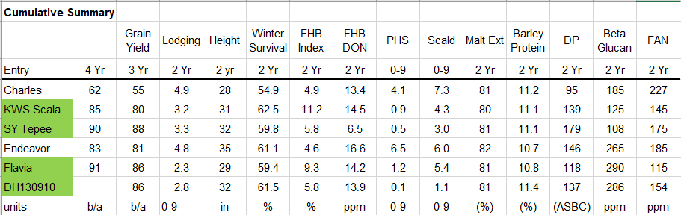

Figure 1: Germination index (GI) phenotypic distributions change over time (TP1, TP2, TP3) based on molecular marker scores at GA20ox1 and MKK3 at the *SD2* locus. Haplotypes of lines are shown that genotypically resemble AAC Synergy (PHS susceptible, high malting quality), Conlon (PHS resistant, moderate malting quality), or are recombinants. N refers to the number of lines in the AAC Synergy/Conlon biparental family that were included in the Cornell spring barley panel and have GI data. Recombinant lines resemble Conlon at TP1 (one week post-physiological maturity) indicating dormancy but more closely resemble AAC Synergy at TP2 (1.5 months post-PM) and TP3 (3 months post-PM).

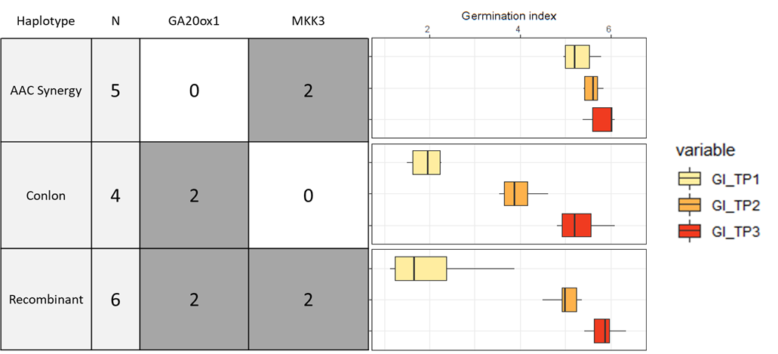

Figure 2: Distribution of raw pre-harvest sprouting data from a European landrace barley panel in 2019.

